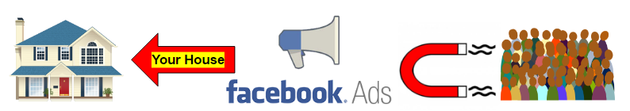
Targeted Facebook Ads That Get Tons Of People Looking At 123 Main Street

As soon as your property goes live on the market we’ll launch a Facebook “Pay Per Click” Advertising Campaign that lets 1000’s of people know your home is for sale.

Not only will we show the ad to other homeowners who live close to your property, we’ll also strategically show it to “most likely to buy” prospects.

For your property, we’ll likely target:

- Renters
- Income $75,000-$250,000
- Married
- Age 34-45

We’ll also show your property to Facebook using Realtors who might already be working with a buyer.

